Physics Problems Solutions

Name
Institutional Affiliations
Course
Professor
Date

Physics Problems Solutions
Problem 3
Consider falling bucket a shown. Suppose the bucket and pulley masse are m=12kg and M=88kg, respectively, and the pulley is a uniform cylinder of radius R=0.5m.
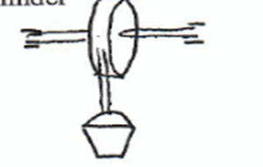
Find
- Angular acceleration of the pulley
=

- Acceleration of the bucket
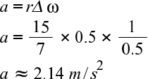
- Angular velocity of the pulley after the bucket has fallen for 5s

- Velocity of the bucket after it has fallen 1m.
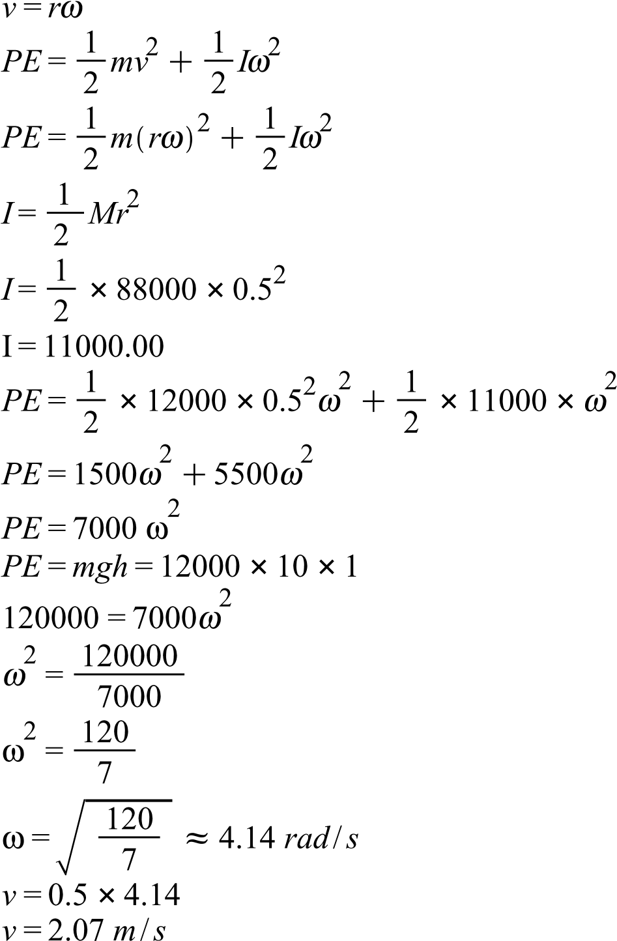
Problem 4
A plumber of mass 74kg just loosens a rusted-in bolt with the help of a 45cm long wrench. He places the wrench in a horizontal position and applies torque by hanging from the end of the wrench. What is the torque applied?
where g= gravitational acceleration

The Assistant of the plumber meets a similar situation but aligns the wrench at an angle of 50⁰ from the vertical.
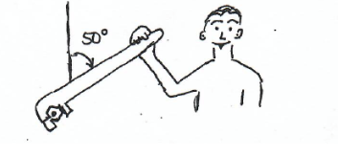
What must his mass be in order for him to use the same technique to loosen the same bolt?

Problem 5
A system of two paint buckets connected by a lightweight rope is released from the rest with the 12kg bucket 2m above the floor. Neglect friction and the inertia of the pulley.
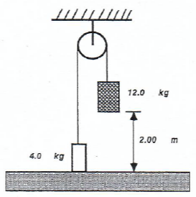
- Find the speed with which this bucket strikes the floor
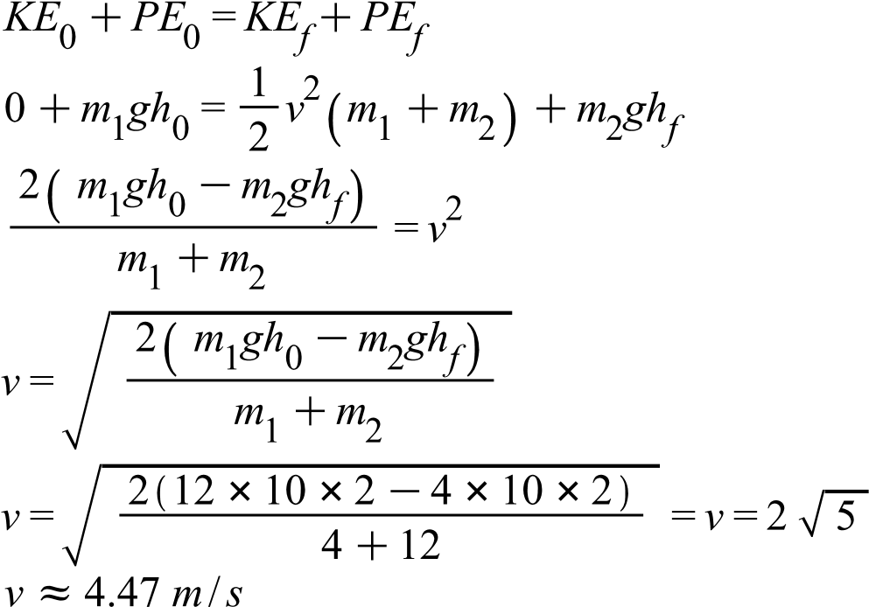
- Describe the motion of the other bucket after the 12kg bucket strikes the floor.
The acceleration and the velocity of the bucket equals zero since the bucket is sitting on a non-moving floor. Therefore the bucket is at rest.
Problem 6
A particle of mass 3kg starts from the rest at a point A and slides around the frictionless loop the loop BDC. Use g=10m/s^2.
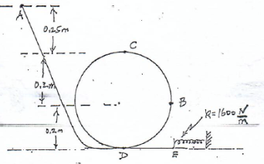
- find the speed of the particle at point B

- Find the magnitude and direction of the acceleration of the particle B, be sure to include the angle between the acceleration and the horizontal

- Find the normal force exerted by the track on the particle at C

- After going round the loop-to-loop, the particle leaves it at D and finally moves along the horizontal exit track DE, where there is friction, on the horizontal truck is 0.6J. Find the maximum compression of the spring.

Problem 7
A block of mass m=3kg is pressed against a spring, compressing it an amount x=0.4m. The block is then released from rest and move along frictionless track AB and then around the frictionless loop-to-loop, of radius R=0.6m, as indicated. The spring constant is k=750N/m
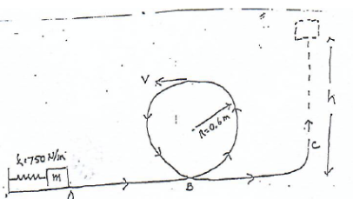
- Find the speed v of the block at the top of the loop-to-loop
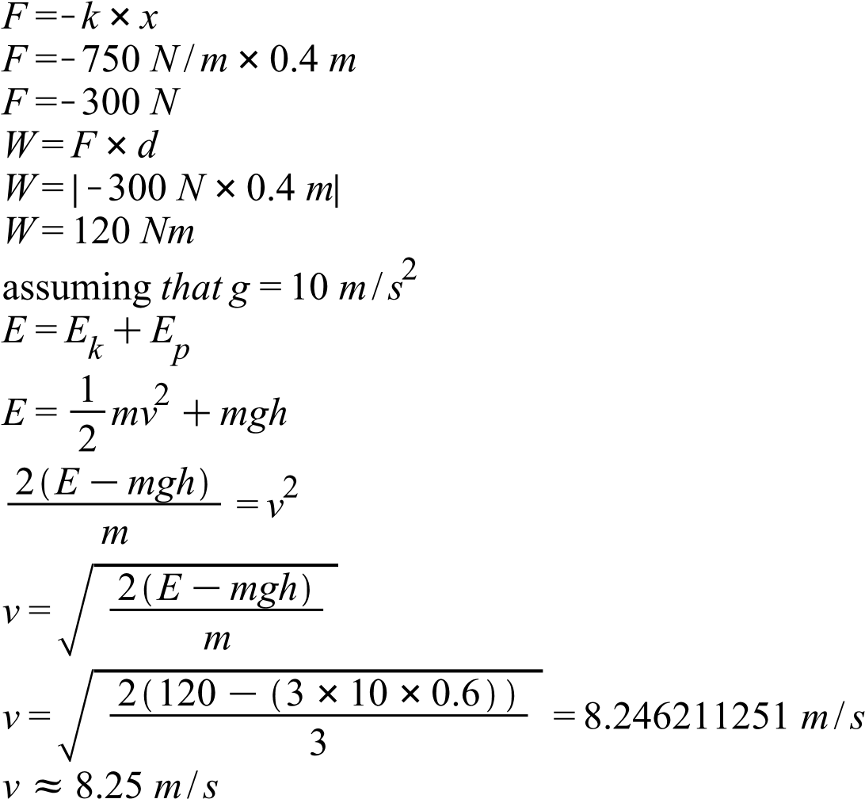
- After going around the loop-to-loop, the block moves along the portion BC of the truck where there is friction and finally leaves the track at C, moving straight upward. Find h, the maximum height reached, if the magnitude of the work done by friction is 15J.

